**About Goodreads**

**Ref:** [**https://en.wikipedia.org/wiki/Goodreads**](https://en.wikipedia.org/wiki/Goodreads)

Goodreads is an American social cataloguing website and a subsidiary of Amazon that allows individuals to search its database of books, annotations, quotes, and reviews. Users can sign up and register books to generate library catalogues and reading lists. They can also create their own groups of book suggestions, surveys, polls, blogs, and discussions. The website's offices are located in San Francisco.

Goodreads was founded in December 2006 and launched in January 2007 by Otis Chandler and Elizabeth Khuri Chandler. In December 2007, the site had 650,000 members and 10,000,000 books had been added. By July 2012, the site reported 10 million members, 20 million monthly visits, and thirty employees. On March 28, 2013, Amazon announced its acquisition of Goodreads, and by July 23, 2013, Goodreads announced their user base had grown to 20 million members.

By July 2019, the site had 90 million members.

**Goodreads Initial Subscription**

**Ref:** [**https://www.goodreads.com/**](https://www.goodreads.com/)

The initial genres offered by Goodreads are as follows.

* Top of Form

Bottom of Form

* Art
* Biography
* Business
* Chick Lit
* Children's
* Christian
* Classics
* Comics
* Contemporary
* Cookbooks
* Crime
* EBooks
* Fantasy
* Fiction
* Gay and Lesbian
* Graphic Novels
* Historical Fiction
* History
* Horror
* Humour and Comedy
* Manga
* Memoir
* Music
* Mystery
* Nonfiction
* Paranormal
* Philosophy
* Poetry
* Psychology
* Religion
* Romance
* Science
* Science Fiction
* Self Help
* Suspense
* Spirituality
* Sports
* Thriller
* Travel
* Young Adult

**My selection**

Genre

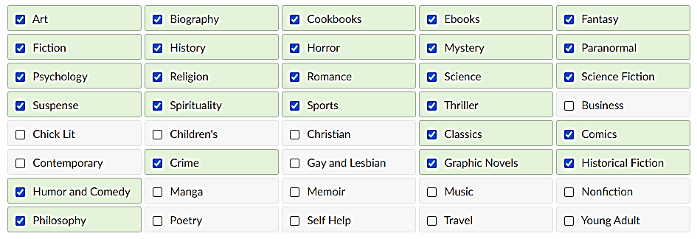

Goodreads ask to rate at least 20 books to get started

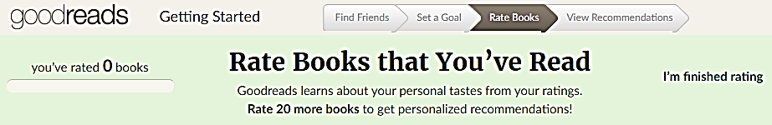

The following are some of the items on specific genres offered to rate right after signing up.

